Ideation Phase
Define the Problem Statements

Date | 29 January 2026
Team ID | SWTID-2026-7933
Project Name | AI FAQ Assistant
Maximum Marks | 2 Marks

Customer Problem Statement Template:
Create a problem statement to understand your customer's point of view. The Customer Problem Statement template helps you focus on what matters to create experiences people will love.
Problem  Statement (PS) | I am  (Customer) | I’m trying to | But | Because | Which makes me feel
A well-articulated customer problem statement allows you and your team to find the ideal solution for the challenges your customers face. Throughout the process, you’ll also be able to empathize with your customers, which helps you better understand how they perceive your product or service.
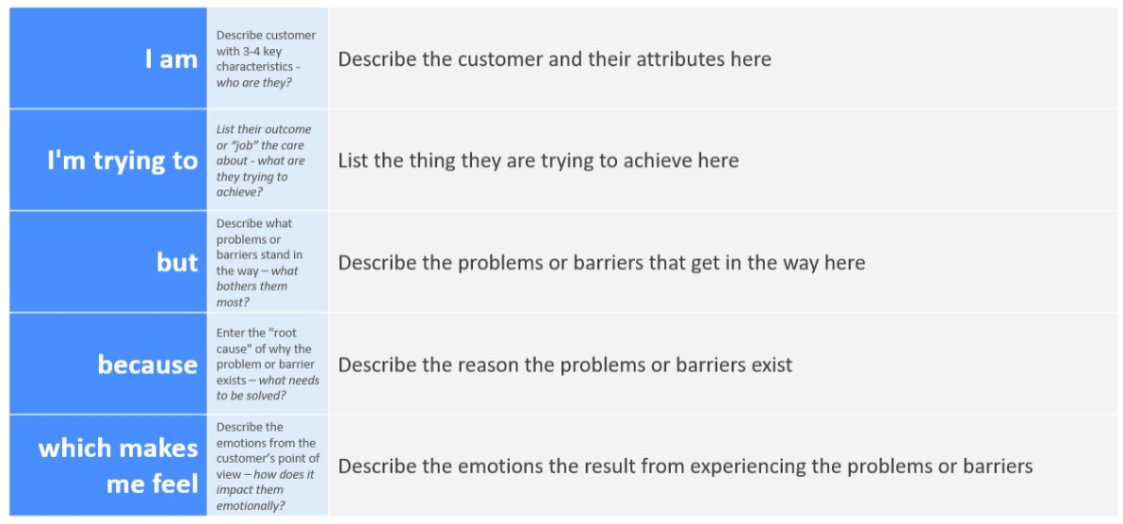
Reference: https://miro.com/templates/customer-problem-statement/ Example:
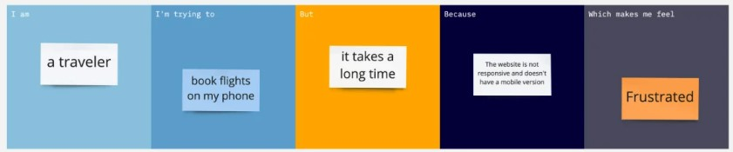
PS-1 | A student who needs quick answers to common  questions | Find accurate information quickly | it takes time to search for answers manually | information may be scattered across different sources | confused and frustarted
PS-2 | A student who wants help with frequently asked questions | get simple and immediate answers | finding the right informati on can be difficult | there may not always be someone  available to answer questions | worried and uncertain

